Tour d’Horizon 2021 and multi-annual TdH trends

Background
- Belgium compiled the results of TdH flights of 2021 in a ‘Report on Tour d’Horizon 2021’ (see Annex 1). The TdH flight programme for 2021 (cf. BA Joint Action Programme) was scheduled as follows:
January/February:………..Denmark
March/April:…………………Germany
May/June:…………………….Sweden
July/August:………………….Belgium
September/October:…….The United Kingdom - Netherlands
November/December:….Norway

- Each of the above CPs was requested by the BA Secretariat prior to OTSOPA 22 to submit their aerial surveillance data for 2021, including the TdH21 mission data. The BA Secretariat subsequently sent the submitted TdH data to Belgium in March 2022.

- DE and NL had to cancel their TdH21 mission. As a result, 5 different TdH missions were carried out by: (in chronological order) Denmark, Sweden, Belgium, The United Kingdom and Norway – a joint surveillance effort which is in line with the BA joint action programme.

- OTSOPA 22 already examined and discussed an advanced draft version of the report. This final version only contains additional info on one UK detection investigation (case of Mariner A, on 07/07/2021) that was still missing in the draft report presented to OTSOPA in May.

Remarks and conclusions
TdH21 results
- The total number of spill detections made during TdH campaigns in 2021 amounts to 35 – of which 32 were identified as oil (as added in the multi-annual overview table below) and 3 as ‘unknown’ substances. No detections of ‘other substances’ were made. 31 oil detections were found connected to offshore installations. 10 flight detections were verifications following receipt of CSN SAT alerts. All detections were systematically reported post-flight by email to the national focal points concerned.

- Some issues that OTSOPA 22 could usefully discuss, are:

- As in previous years, a large variation in n° of detections per TdH mission can be observed between countries. This is not only due to variable weather conditions, but also due to differences in flight patterns and approaches. Belgium believes that flight routes and patterns can be optimised – i.e. to check as much as platforms as possible, not only by SLAR but also by means of visual verification.
- Although aircrew consider the CSN support to TdH missions a useful operational tool, the platform identification made available in the CSN alert reports can be improved. This addition was officially requested by the BA to EMSA, and will, once operational, improve the efficiency of TDH missions. The two improvements requested by Bonn Agreement are 1) include platforms layer information in SEG and CSN alert report and 2) include a new category in the SEG oil spill feedback window to better identify TdH/CEPCO operations. These are currently ongoing improvements.
- Belgium thanks the CPs that send us their detailed TDH mission report!

Multi-annual trends in TdH oil detections

- From the TdH 2021 report and the Table 1 and Figure 1 below, which summarize the confirmed oil detections made during all TdH campaigns in the framework of the Bonn Agreement since 1999, the following can be concluded:

- The TdH21 campaigns jointly resulted in 32 oil detections, of which 31 were associated to an offshore installation. 4 oil detections consisted of major oil volumes (min. oil vol. > 1 m³). These are quite average results when comparing the 2021 data with the other annual data in the period 1999-2021.

- Strong annual fluctuations can be found in annual TdH detections, and the lack of a clear trend in number of TdH detections over the last 23 years. This seems contrary to, for example, the significantly decreasing trend in oil pollution from ships. But it should be nuanced that such a comparison is difficult to make, since most TdH detections are assessed to be permitted OIW discharges, whilst oil spills detected in the wake of a ship are generally the result of an illegal discharge (violation of MARPOL Annex I discharge standards).

Year | N° TdH flight hours | N° of confirmed oil detections | N° of confirmed oil detections connected to offshore installations | N° of ‘major’ oil detections  (> 1 m³ min.vol.)
2021 | 61.47 | 32 | 31 | 4
2020 | 55.88 | 27 | 25 | 2
2019 | 80.82 | 36 | 33 | 4
2018 | 97.83 | 33 | 32 | 5
2017 | 101.95 | 54 | 48 | 9
2016 | 86.75 | 14 | 14 | 3
2015 | 42.58 | 4 | 4 | 1
2014 | 99.3 | 58 | 54 | 10
2013 | 98.88 | 36 | 30 | 4
2012 | 69.57 | 16 | 13 | 1
2011 | 50.64 | 7 | 4 | 1
2010 | 82.19 | 45 | 39 | 7
2009 | 85.45 | 23 | 21 | 1
2008 | 56.39 | 34 | 25 | 4
2007 | 38.27 | 19 | 15 | 6
2006 | 73.11 | 24 | 21 | 3
2005 | 50.71 | 17 | 3 | (-) ²
2004 | 82.67 | -50 | 40 | (-)
2003 | 50.08 | -23 | 6 | (-)
2002 | 81.82 | -33 | 23 | (-)
2001 | 63.68 | -60 | 51 | (-)
2000 | 84.3 | -59 | 49 | (-)
1999 | 81.3 | -34 | 24 | (-)
Table 1 – Multi-annual overview of joint TdH flight effort and confirmed oil detections for period 1999-2021.

Fig. 1 – Multi-annual trends in confirmed oil detections associated with offshore installations, as observed during joint TdH campaigns for the period 1999-2021.

Report on Tour de Horizon flights carried out during 2021
Introduction
The Tour de Horizon (TdH) flights for 2021 were flown as follows: January: Denmark; June: Sweden; July: Belgium; September: the United Kingdom and December; Norway. The flights took place over 15 flight days between 14 January and 16 December 2021, more specifically:
- 14-16 January (DK)
- 02-03 June (SE)
- 05-09 July (BE)
- 03-07 September (UK)
- 07 and 16 December (NO)
All flight data have been sent to the BA Secretariat for compilation.
Detections
- A total of 35 detections were made during the 5 TdH 2021 campaigns (27 in British area and 8 in Norwegian area). 32 detections were identified as mineral oil. Two detections could not be visually verified due to low clouds and therefore have been categorized as ‘unknown substance’. SE observed 1 spill but did not have sufficient time to inspect the spill due to limited fuel and was also categorized as ‘unknown’ substance.
- 34 detections were found directly associated with offshore platforms (27 in UK area, and 7 in NO area), 31 of them consisted of mineral oil. The source of pollution of 1 single detection consisting of oil could not be established.
- Of the 32 mineral oil detections, minimum 4 detections (~min. vol.) and maximum 7 detections (~max. vol.) consisted of major oil volumes - i.e. volume of more than 1 m³. A more detailed overview of the number of oil detections per volume category is given below.
Volume category | N° of oil slicks  (min. vol.) | N° of oil slicks  (max. vol.)
10-100 m³ | 1 | 3
1-10 m³ | 3 | 4
0.5-1 m³ | 1 | 4
0.1-0.5 m³ | 2 | 4
< 0.1 m³ | 23 | 15
CSN SAT support
As in previous years, CSN satellite surveillance support was made available for the TdH21 missions, through a direct request procedure between TdH aircrew and EMSA. Of the 35 TdH detections made in 2021, 10 were reported as verifications of an initial CSN satellite detection alert. EMSA received two requests to provide support to TdH21 missions: June and July 2021. During the mission held in June, CSN service detected 53 possible spills but as CSN alert report email notifications were not requested to be activated by Sweden, no alert reports were received by the user. During July’s mission, all the CSN alert reports generated by a potential oil spill in the BA region were sent to the user (Belgium).
Flight routes
Five flight maps have also been added to this report. The maps visualize the flight routes of the performed TdH21 missions and the degree of coverage of the central part of the North Sea where most offshore installations are located. They also show the locations of the detections made during the various TdH21 campaigns.
Detection investigation
The overview of the national inspectors’ detection investigation is added on pp.9-11 of the TdH 2021 report. This detection investigation summary shows that of the detections associated with offshore platforms, the vast majority were reported as normal produced water discharges. Two detections with oil vol. >1 m³ associated to offshore installations concerned non-compliance cases (MARINER A, 07/07/2021: detection part of non-compliance submission; NINIAN CENTRAL, 03/09/2021: non-compliance produced water discharge).
TOUR D’HORIZON 2021 RESULTS

1. SUMMARY OF RESULTS
Summary of data relating to Tour d’Horizon (TdH) flights during 2021
Country | No. of flights | No. of flight hours |  |  | No. of detections |  |  | No of detections identified as oil | Estimated volume m³ | No of ‘other substance’ detections | No of ‘unknown’ detections | No. of sources/polluters |  |  |  | Remarks
 |  | Daylight | Darkness | Sum | Daylight | Darkness | Sum |  |  |  |  | Rigs | Ships | (Unknown) | Total
Belgium | 5 | 19:30 | 00:00 | 19:30 | 20 | 0 | 20 | 18 | 3.70 | 0 | 2 | 19 | 0 | 1 | 20
Denmark | 3 | 09:34 | 01:13 | 10:47 | 0 | 0 | 0 | 0 | - | 0 | 0 | 0 | 0 | 0 | 0
Germany | 0 | 00:00 | 00:00 | 00:00 | 0 | 0 | 0 | 0 | - | 0 | 0 | 0 | 0 | 0 | 0 | 1)
Netherlands | 0 | 00:00 | 00:00 | 00:00 | 0 | 0 | 0 | 0 | - | 0 | 0 | 0 | 0 | 0 | 0 | 2)
Norway | 2 | 09:20 | 00:00 | 09:20 | 5 | 0 | 5 | 5 | 0.04 | 0 | 0 | 5 | 0 | 0 | 5
Sweden | 2 | 11:11 | 00:00 | 11:11 | 3 | 0 | 3 | 2 | 20.61 | 0 | 1 | 3 | 0 | 0 | 3 | 3)
UK | 3 | 10:40 | 00:00 | 10:40 | 7 | 0 | 7 | 7 | 1.95 | 0 | 0 | 7 | 0 | 0 | 7 | 4)
Total | 15 | 60:15 | 01:13 | 61:28 | 35 | 0 | 35 | 32 | 26.29 | 0 | 3 | 34 | 0 | 1 | 35
1) DE had to cancel its TdH mission due to non-availablity of aircraft.
2) NL had to cancel its TdH mission due to technical problems.
3) The SE crew was unable to investigate 1 spill in detail due to lack of fuel (=UNK).
4) For 2 oil spills the UK crew was unable to quantify the oil pollution due to limited fuel endurance.

2. OVERVIEW OF DETECTIONS/OBSERVATIONS PER CONTRACTING PARTY
2.1 DENMARK: 14-16 January 2021.
- DK reported 0 observations during their TDH21 mission.
2.2 SWEDEN: 02-03 June 2021.
No | Date (dd.mm.yy) | Time (UTC) | Position (dec. degr.) |  | CP Area | Min. Quan.(m³) | Max. Quan.(m³) | Source ID | Pollution type
 |  |  | N | E /(W)
1 | 03/06/2021 | 10:35 | 60.7628 | 3.4969 | NO | 9.11 | 55.84 | TROLL B | OIL
2 | 03/06/2021 | 10:52 | 61.3150 | 1.8664 | NO | 11.50 | 55.00 | STATFJORD C | OIL
3 | 03/06/2021 | 11:46 | 59.2775 | 1.4972 | UK | - | - | HARDING B | UNK

- None of the flight detections was a verification of a CSN alert. The EMSA CSN alert report email notifications were not requested to be activated by Sweden, and therefore
no flight and observation was made based on the CSN alert reports
- In-flight reporting was performed. The detection was also reported post-flight by email, to the National Focal Point concerned.
- For spill N°3 the SE crew was unable to do an investigation due to lack of fuel. Therefore, the spill is categorized as ‘UNK’.

2.3 BELGIUM: 05-09 July 2021.
No | Date (dd.mm.yy) | Time (UTC) | Position (dec. degr.) |  | CP Area | Min. Quan.(m³) | Max. Quan.(m³) | Source ID | Pollution type
 |  |  | N | E /(W)
1 | 06/07/2021 | 12:55 | 58.2886 | 0.1833 | UK | 0.03 | 0.33 | SCOTT | OIL
2 | 06/07/2021 | 13:11 | 58.4611 | 0.2333 | UK | 0.04 | 0.36 | PIPER B | OIL
3 | 06/07/2021 | 13:21 | 58.4489 | 0.2500 W | UK | 0.05 | 0.56 | CLAYMORE | OIL
4 | 07/07/2021 | 10:54 | 60.8039 | 1.4492 | UK | 0.00 | 0.03 | NINIAN SOUTH | OIL
5 | 07/07/2021 | 10:56 | 60.8569 | 1.4728 | UK | 0.00 | 0.01 | NINIAN CENTRAL | OIL
6 | 07/07/2021 | 11:10 | 61.1011 | 1.0739 | UK | 0.01 | 0.06 | CORMORANT A | OIL
7 | 07/07/2021 | 11:19 | 61.2150 | 0.9167 | UK | 0.01 | 0.05 | WESTERN ISLES | OIL
8 | 07/07/2021 | 11:28 | 61.2750 | 1.5117 | UK | 0.00 | 0.02 | TERN A | OIL
9 | 07/07/2021 | 12:02 | 61.4472 | 2.1494 | NO | 0.05 | 0.74 | SNORRE A | OIL
10 | 07/07/2021 | 12:15 | 61.2131 | 2.2692 | NO | 0.00 | 0.02 | GULFAKS C | OIL
11 | 07/07/2021 | 12:15 | 61.2031 | 2.1953 | NO | 0.00 | 0.02 | GULFAKS B | OIL
12 | 07/07/2021 | 12:15 | 61.1756 | 2.1828 | NO | 0.00 | 0.03 | GULFAKS A | OIL
13 | 07/07/2021 | 12:42 | 60.8342 | 2.7303 | NO | 0.08 | 0.85 | - | OIL
14 | 07/07/2021 | 13:37 | 59.6083 | 1.5117 | UK | 0.00 | 0.04 | BERYL B | OIL
15 | 07/07/2021 | 13:38 | 59.5439 | 1.5347 | UK | 0.01 | 0.05 | BERYL A | OIL
16 | 07/07/2021 | 13:53 | 59.5900 | 1.0569 | UK | 2.88 | 20.15 | MARINER A | OIL
17 | 08/07/2021 | 10:16 | 58.2283 | 1.1072 | UK | - | - | BALMORAL | UNK
18 | 08/07/2021 | 10:22 | 58.0586 | 1.0756 | UK | - | - | ALBA NORTHERN | UNK
19 | 08/07/2021 | 10:32 | 57.7283 | 0.9667 | UK | 0.50 | 4.27 | FORTIES A | OIL
20 | 08/07/2021 | 10:33 | 57.7247 | 0.8333 | UK | 0.02 | 0.23 | FORTIES C | OIL

- Ten of these flight detections were verifications of a CSN SAT alert: No. 2,3,4,5,6,7,8,9,11 and 17.
- In-flight reporting performed. All detections were reported post-flight by email, to the National Focal Point concerned.

2.4 UNITED KINGDOM: 03-07 September 2021.
No | Date (dd.mm.yy) | Time (UTC) | Position (dec. degr.) |  | CP Area | Min. Quan.(m³) | Max. Quan.(m³) | Source ID | Pollution type
 |  |  | N | E/(W)
1 | 03/09/2021 | 12:40 | 60.8558 | 1.46915 | UK | 1.51 | 9.65 | NINIAN CENTRAL | OIL
2 | 03/09/2021 | 13:35 | 61.6114 | 1.3029 | UK | 0.00 | 0.05 | MAGNUS | OIL
3 | 03/09/2021 | 13:55 | 61.4486 | 2.14175 | NO | 0.05 | 0.76 | SNORRE A | OIL
4 | 03/09/2021 | 15:35 | 58.4490 | 0.2717 W | UK | 0.23 | 3.49 | CLAYMORE | OIL
5 | 05/09/2021 | 12:30 | 58.0472 | 1.40255 | UK | 0.15 | 1.58 | ANDREW | OIL
6 | 05/09/2021 | 12:47 | - | - | UK | - | - | FORTIES ALPHA | OIL
7 | 05/09/2021 | 12:49 | - | - | UK | - | - | FORTIES CHARLIE | OIL

- Two oil slicks linked to FORTIES ALPHA and FORTIES CHARLIE were observed but the crew was unable to quantify the pollution due to limited fuel endurance.
- In-flight reporting performed. All detections were reported post-flight by email, to the National Focal Point concerned.
- None of the flight detections was a verification of a CSN alert. EMSA was not requested to provide CSN support to this operation and therefore, CSN alert report
email notifications were not activated to any specific email recipient.

2.5 NORWAY: 07 and 16 December 2021
No | Date (dd.mm.yy) | Time (UTC) | Position (dec. degr.) |  | CP Area | Min. Quan.(m³) | Max. Quan.(m³) | Source ID | Pollution type
 |  |  | N | E /(W)
1 | 16/12/2021 | 12:23 | 58.3600 | 0.3300 | UK | 0.03 | 0.35 | Scott | OIL
2 | 16/12/2021 | 11:40 | 57.7300 | 0.8800 | UK | 0.00 | 0.03 | Forties Delta | OIL
3 | 16/12/2021 | 11:36 | 57.6000 | 0.7500 | UK | 0.00 | 0.04 | Forties Charlie | OIL
4 | 16/12/2021 | 11:40 | 57.6000 | 0.8000 | UK | 0.00 | 0.05 | Forties Delta | OIL
5 | 16/12/2021 | 11:43 | 57.8000 | 0.8700 | UK | 0.01 | 0.08 | Forties Alpha | OIL

TOUR D’HORIZON 2021 – DETECTION INVESTIGATION SUMMARY
SWEDEN:
Date  (ddmmyy) | Time  (UTC) | Platform | Reported quantity (m³) |  | Government inspectors assessment
 |  |  | Min. | Max.
03/06/2021 | 10:35 | TROLL B | 9.11 | 55.84 | NO inspectors assessment: observation within normal activity and permit limits – low wind conditions
03/06/2021 | 10:52 | STATFJORD C | 11.50 | 55.00 | NO inspectors assessment: observation within normal activity and permit limits – low wind conditions
03/06/2021 | 11:46 | HARDING B | - | - | UK inspectors assessment: Operator contacted. Produced water within permitted discharge limit. No other discharge.

BELGIUM:
Date  (ddmmyy) | Time  (UTC) | Platform | Reported quantity (m³) |  | Government inspectors assessment
 |  |  | Min. | Max.
06/07/2021 | 12:55 | SCOTT | 0.03 | 0.33 | UK inspectors assessment: Operator contacted. Produced water within permitted discharge limit. No other discharge.
06/07/2021 | 13:11 | PIPER B | 0.04 | 0.36 | UK inspectors assessment: Operator not contacted. On review of photographs and report, inspector concluded discharge was likely to be as a result of a normal permitted produced water discharge from the platform.
06/07/2021 | 13:21 | CLAYMORE | 0.05 | 0.56 | UK inspectors assessment: Operator not contacted. On review of photographs and report, inspector concluded discharge was likely to be as a result of a normal permitted produced water discharge from the platform.
07/07/2021 | 10:54 | NINIAN SOUTH | 0.00 | 0.03 | UK inspectors assessment: Operator contacted. Produced water within permitted discharge limit. No other discharge.
07/07/2021 | 10:56 | NINIAN CENTRAL | 0.00 | 0.01 | UK inspectors assessment: Operator contacted. Produced water within permitted discharge limit. No other discharge.
07/07/2021 | 11:10 | CORMORANT A | 0.01 | 0.06 | UK inspectors assessment: Operator contacted. Produced water within permitted discharge limit. No other discharge.
07/07/2021 | 11:19 | WESTERN ISLES | 0.01 | 0.05 | UK inspectors assessment: Operator contacted. Produced water within permitted discharge limit. No other discharge.
07/07/2021 | 11:28 | TERN A | 0.00 | 0.02 | UK inspectors assessment: Operator contacted. Produced water within permitted discharge limit. No other discharge.
07/07/2021 | 12:02 | SNORRE A | 0.05 | 0.74 | NO inspectors assessment: spill was within normal activity and permit limits
07/07/2021 | 12:15 | GULFAKS C | 0.00 | 0.02 | NO inspectors assessment: spill was within normal activity and permit limits
07/07/2021 | 12:15 | GULFAKS B | 0.00 | 0.02 | NO inspectors assessment: spill was within normal activity and permit limits
07/07/2021 | 12:15 | GULFAKS A | 0.00 | 0.03 | NO inspectors assessment: spill was within normal activity and permit limits
07/07/2021 | 13:37 | BERYL B | 0.00 | 0.04 | UK inspectors assessment: Operator not contacted. On review of photographs and report, inspector concluded discharge was likely to be as a result of a normal permitted produced water discharge from the platform.
07/07/2021 | 13:38 | BERYL A | 0.01 | 0.05 | UK inspectors assessment: Operator not contacted. On review of photographs and report, inspector concluded discharge was likely to be as a result of a normal permitted produced water discharge from the platform.
07/07/2021 | 13:53 | MARINER A | 2.88 | 20.15 | UK inspectors assessment: Operator contacted. Equinor confirmed the sheen is part of non-compliance submissions being investigated by OPRED. No further action required.
08/07/2021 | 10:16 | BALMORAL | - | - | UK inspectors assessment: Operator contacted. Sheen linked to pipeline flushing operation during decommissioning activities. The operator had a permit for the flushing operations however, there was more oil discharged than expected.
08/07/2021 | 10:22 | ALBA NORTHERN | - | - | UK inspectors assessment: Operator contacted. Produced water within permitted discharge limit. No other discharge.
08/07/2021 | 10:32 | FORTIES A | 0.50 | 4.27 | UK inspectors assessment: Operator contacted. Produced water within permitted discharge limit. No other discharge.
08/07/2021 | 10:33 | FORTIES C | 0.02 | 0.23 | UK inspectors assessment: Operator not contacted. On review of photographs and report, inspector concluded discharge was likely to be as a result of a normal permitted produced water discharge from the platform.

UNITED KINGDOM:
Date  (ddmmyy) | Time  (UTC) | Platform | Reported quantity (m³) |  | Government inspectors assessment
 |  |  | Min. | Max.
03/09/2021 | 12:40 | NINIAN CENTRAL | 1.51 | 9.65 | UK inspectors assessment: Operator contacted. Elevated oil in produced water discharge due to pre-shutdown hot flushing. PON1 report submitted on 03/09/21 for non-compliance produced water discharge.
03/09/2021 | 13:35 | MAGNUS | 0.00 | 0.05 | UK inspectors assessment: Operator not contacted. On review of photographs and report, inspector concluded discharge was likely to be as a result of a normal permitted produced water discharge from the platform.
03/09/2021 | 13:55 | SNORRE A | 0.05 | 0.76 | NO inspectors assessment: observation was oil in produced water within legal limits
03/09/2021 | 15:35 | CLAYMORE | 0.23 | 3.49 | UK inspectors assessment: Operator not contacted. On review of photographs and report, inspector concluded discharge was likely to be as a result of a normal permitted produced water discharge from the platform.
05/09/2021 | 12:30 | ANDREW | 0.15 | 1.58 | UK inspectors assessment: Operator contacted. Produced water within permitted discharge limit. No other discharge.

NORWAY:
Date  (ddmmyy) | Time  (UTC) | Platform | Reported quantity (m³) |  | Government inspectors assessment
 |  |  | Min. | Max.
16/12/2021 | 12:23 | Scott | 0.03 | 0.35 | UK inspectors assessment: Report not received until requested to complete this report. Operator not contacted. On review of photographs and report, inspector concluded discharge was likely to be as a result of a normal permitted produced water discharge from the platform.
16/12/2021 | 11:40 | Forties Delta | 0.00 | 0.03 | UK inspectors assessment: Report not received until requested to complete this report. Operator not contacted. On review of photographs and report, inspector concluded discharge was likely to be as a result of a normal permitted produced water discharge from the platform.
16/12/2021 | 11:36 | Forties Charlie | 0.00 | 0.04 | UK inspectors assessment: Report not received until requested to complete this report. Operator not contacted. On review of photographs and report, inspector concluded discharge was likely to be as a result of a normal permitted produced water discharge from the platform.
16/12/2021 | 11:40 | Forties Delta | 0.00 | 0.05 | UK inspectors assessment: Report not received until requested to complete this report. Operator not contacted. On review of photographs and report, inspector concluded discharge was likely to be as a result of a normal permitted produced water discharge from the platform.
16/12/2021 | 11:43 | Forties Alpha | 0.01 | 0.08 | UK inspectors assessment: Report not received until requested to complete this report. Operator not contacted. On review of photographs and report, inspector concluded discharge was likely to be as a result of a normal permitted produced water discharge from the platform.

TOUR D’HORIZON 2021 – FLIGHT MAPS
DENMARK: 14-16 January 2021.
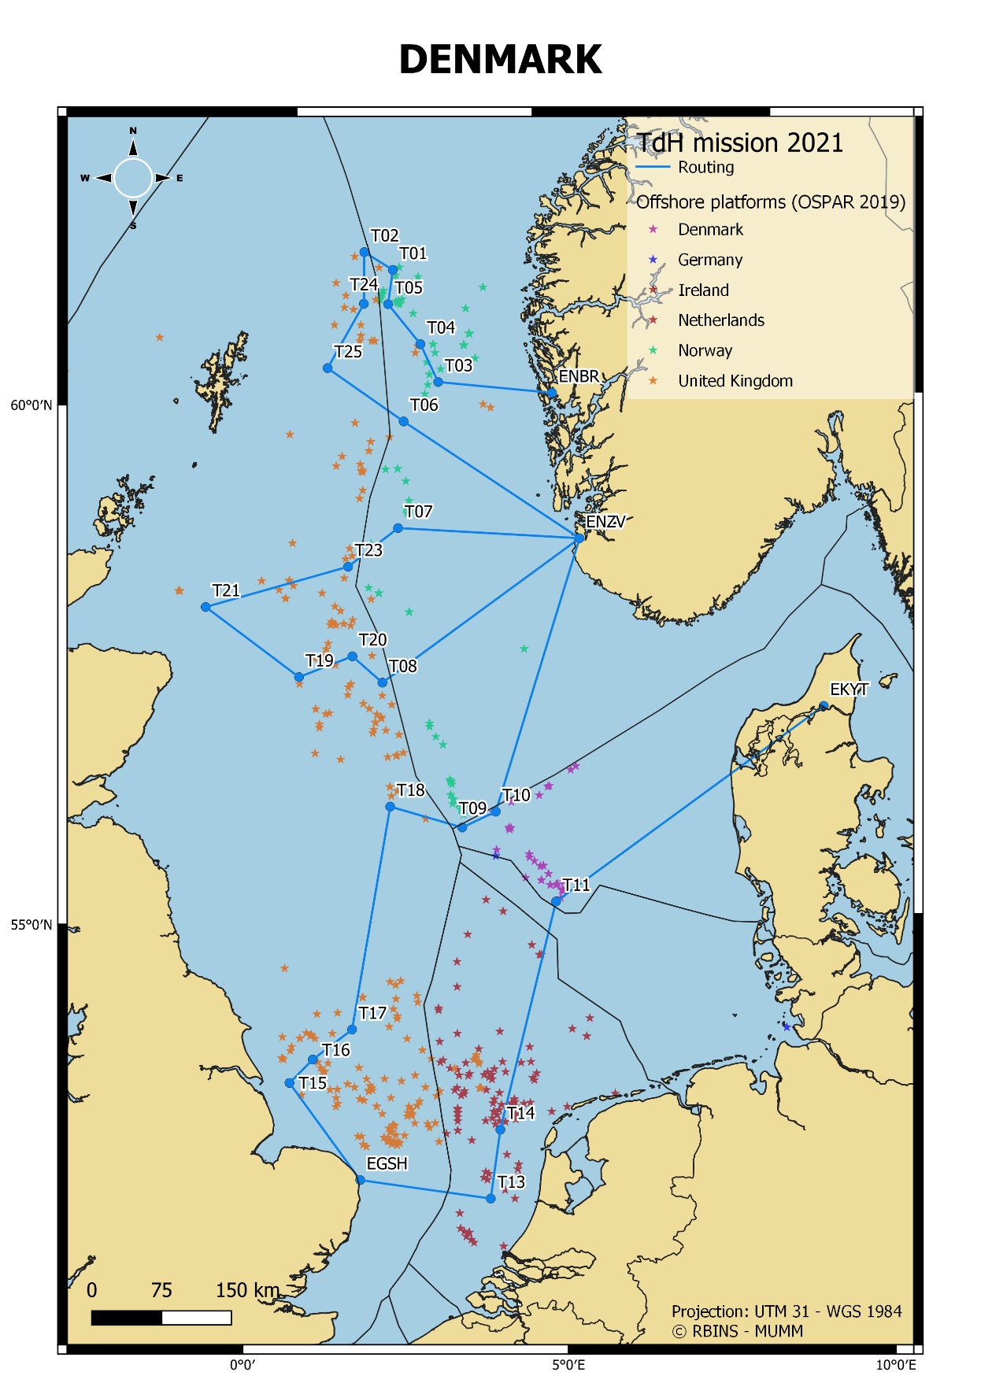

SWEDEN: 02-03 June 2021.
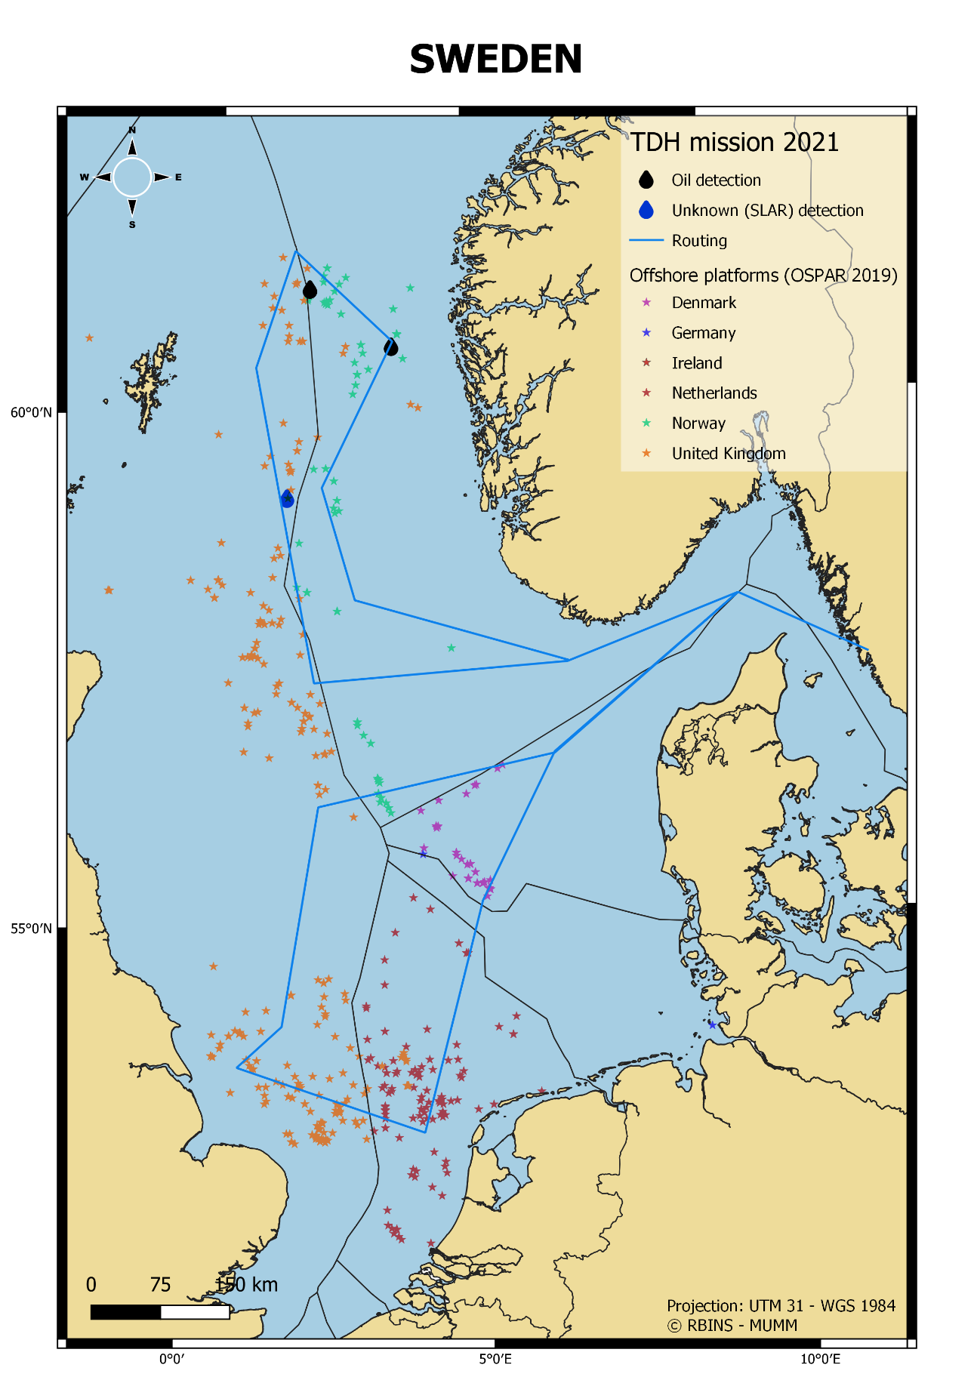

BELGIUM: 05-09 July 2021.
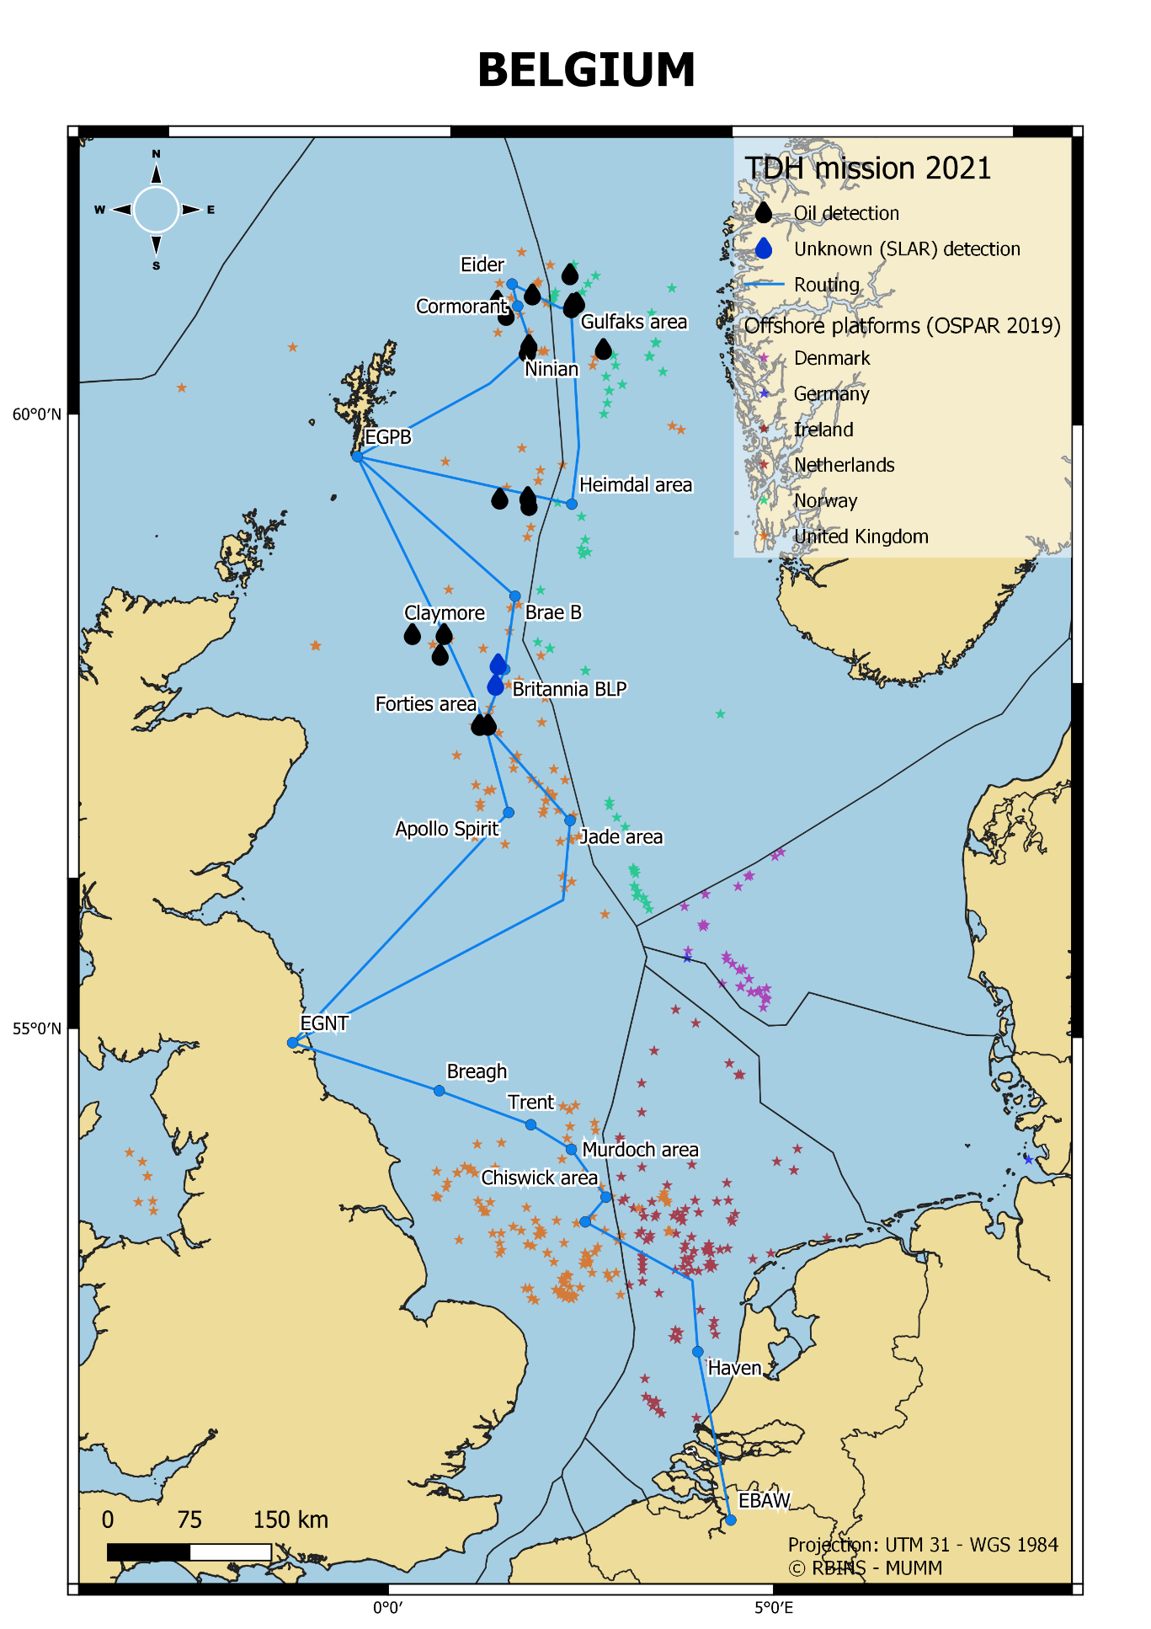

UNITED KINGDOM: 03-07 September 2021.
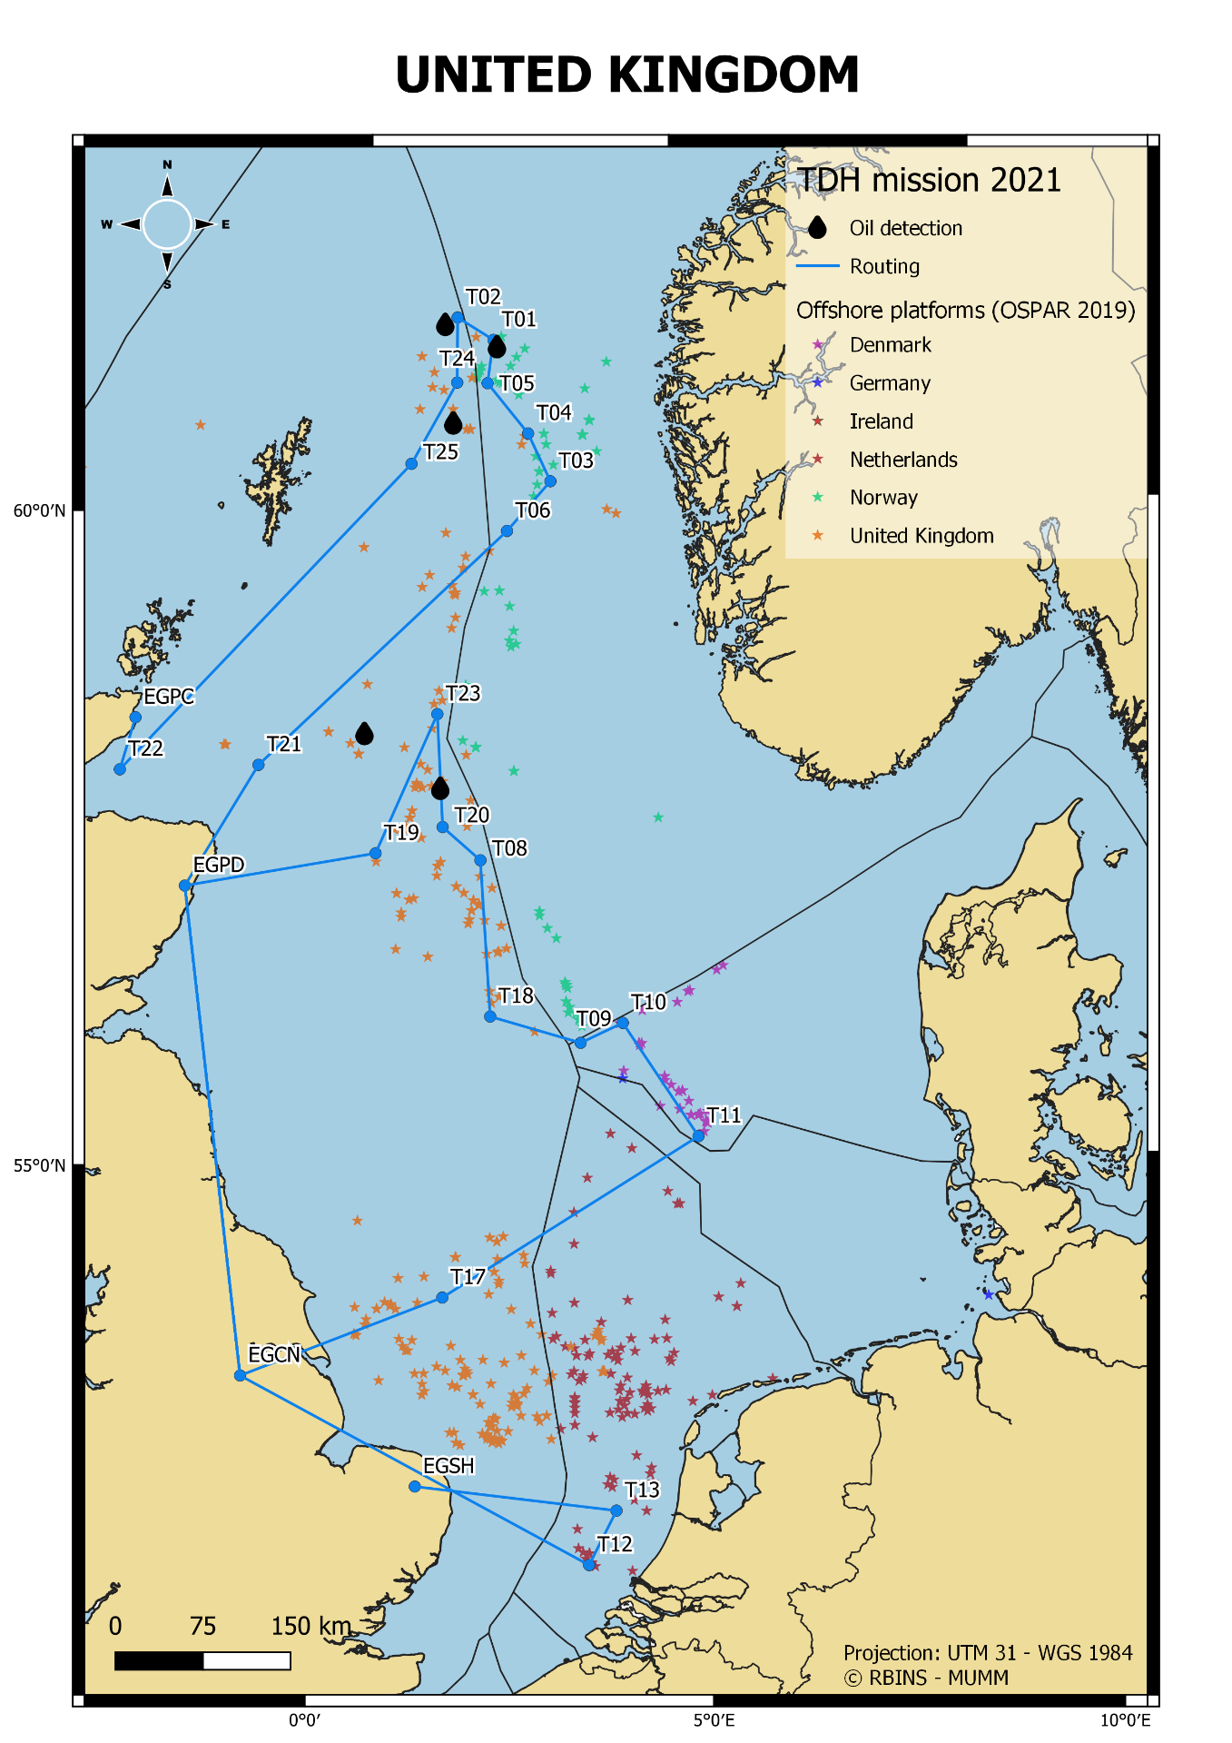

NORWAY: 07 and 16 December 2021.
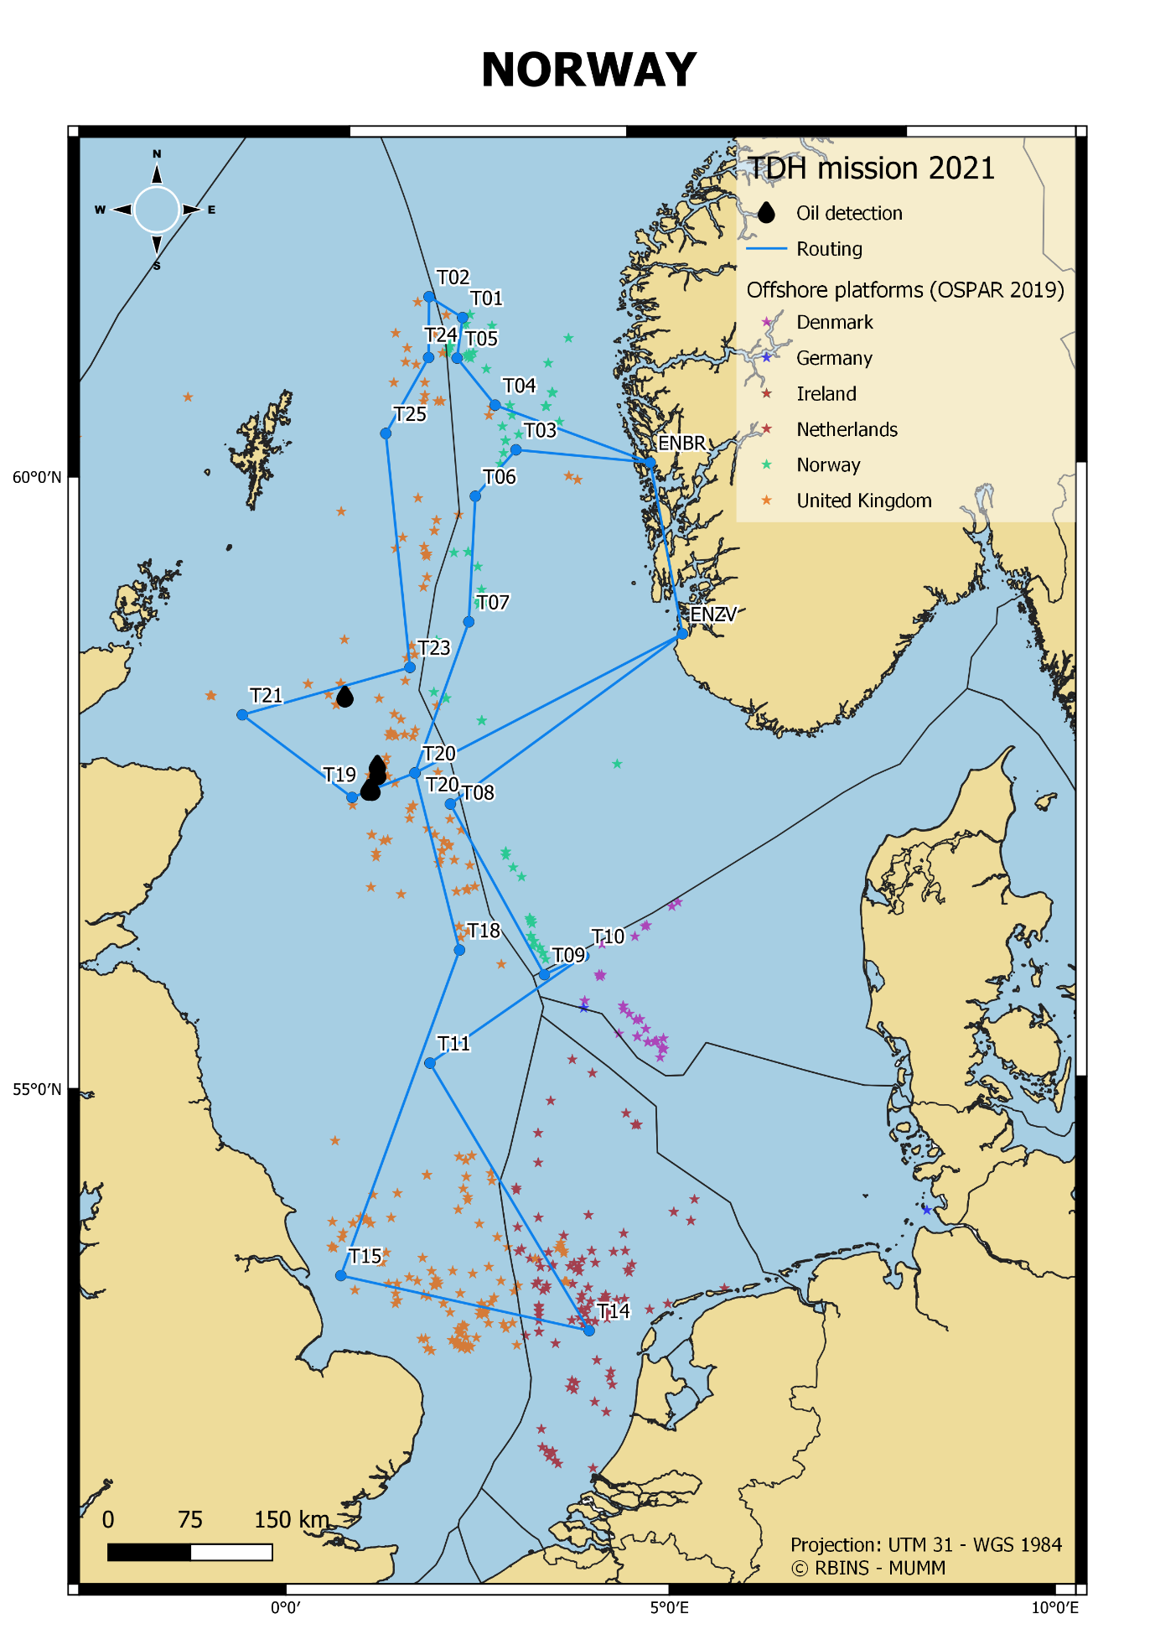

For the period 1999-2005, TdH data have been derived from the general TdH table in the BA annual surveillance reports, which only reflect total number of detections (oil + other substances + unknowns) but not the total number of ‘major’ oil detections (>1 m³min.vol.) – therefore these data are still missing for these earlier years. More detailed info could be added from 2006 onwards, when Belgium started compiling the annual TDH reports.

