Tour d’Horizon 2022 and multi-annual TdH trends

Tour d’Horizon Report 2022
- Belgium compiled the results of TdH flights of 2022 in a ‘(Draft) Report on Tour d’Horizon 2022’ (see Annex 1). The TdH flight programme for 2022 (cf. BA Joint Action Programme) was scheduled as follows:
January/February:………..Germany
March/April:…………………Sweden
May/June:…………………….Norway
July/August:………………….United Kingdom
September/October:…….Belgium
October/November:……..Denmark
November/December:….The Netherlands

Each of the above CPs was requested by the BA Secretariat prior to OTSOPA 22 to submit their aerial surveillance data for 2022, including the TdH22 mission data. The BA Secretariat subsequently sent the submitted TdH data to Belgium in April 2023. Not all flight data was sent to the BA Secretariat for compilation before this deadline. Regrettably Denmark wasn’t able to provide its flight data.

- Unfortunately, DE and NL had to cancel their TdH22 mission. As a result, only 5 different TdH missions were carried out by: (in chronological order) Sweden, Norway, The United Kingdom, Belgium and Denmark – resulting in a joint surveillance effort which is in line with the BA joint action programme.
Remarks and conclusions
TdH22 results
- The total number of spill detections made during TdH campaigns in 2022 amounts to 25 – of which 23 were identified as oil (as added in the multi-annual overview table below) and 2 as ‘unknown’ substances. No detections of ‘other substances’ were made. 22 oil detections were found connected to offshore installations. 3 flight detections were verifications following receipt of CSN SAT alerts. All detections were systematically reported post-flight by email to the national focal points concerned.

- Some issues that OTSOPA/BONN 23 could usefully discuss, are:

- As in previous years, a large variation in n° of detections per TdH mission can be observed between countries. This is not only due to variable weather conditions. It is probably also due to differences in flight patterns/approaches. Belgium believes that flight routes and patterns can be optimised – i.e. to check as much as platforms as possible, not only by SLAR but also by means of visual verification.
- Although aircrew consider the CSN support to TdH missions a useful operational tool, the platform identification made available in the CSN alert reports can be improved. This addition was officially requested by the BA to EMSA, and will, once operational, improve the efficiency of TDH missions. The two improvements requested by Bonn Agreement are 1) include platforms layer information in SEG and CSN alert report and 2) include new category in the SEG oil spill feedback window for better identify TdH/CEPCO operations are currently ongoing as stated in EMSA’s presentation.
- Still not all countries follow the agreed reporting procedures. From own (positive) experience, Belgium would recommend using a liaison officer back in the home office whose objective is to facilitate the TdH detection reporting to NFPs - which is in line with the TdH reporting recommendations listed in the AOH.
- Belgium thanks the CPs that send us their detailed TDH mission report!

Multi-annual trends in TdH oil detections
- From the TdH 2022 report and the Table 1 and Figure 1 below, which summarize the confirmed oil detections made during all TdH campaigns in the framework of the Bonn Agreement since 2006, the following can be concluded:

- The TdH22 campaigns jointly resulted in 25 oil detections, of which 22 were associated to an offshore installation, and 2 oil detections consisted of major oil volumes (min. oil vol. > 1 m³). These are quite average results when comparing the 2022 data with the other annual data in the period 1999-2022.

- Strong annual fluctuations can be found in annual TdH detections, and the lack of a clear trend in number of TdH detections over the last 24 years. This seems contrary to, for example, the significantly decreasing trend in oil pollution from ships. But it should be nuanced that such a comparison is difficult to make, since most TdH detections are assessed to be permitted OIW discharges, whilst oil spills detected in the wake of a ship are generally the result of an illegal discharge (violation of MARPOL Annex I discharge standards).
Year | N° TdH flight hours | N° of confirmed oil detections | N° of confirmed oil detections connected to offshore installations | N° of ‘major’ oil detections  (> 1 m³ min.vol.)
2022 | 60.08 | 25 | 22 | 2
2021 | 61.47 | 32 | 31 | 4
2020 | 55.88 | 27 | 25 | 2
2019 | 80.82 | 36 | 33 | 4
2018 | 97.83 | 33 | 32 | 5
2017 | 101.95 | 54 | 48 | 9
2016 | 86.75 | 14 | 14 | 3
2015 | 42.58 | 4 | 4 | 1
2014 | 99.3 | 58 | 54 | 10
2013 | 98.88 | 36 | 30 | 4
2012 | 69.57 | 16 | 13 | 1
2011 | 50.64 | 7 | 4 | 1
2010 | 82.19 | 45 | 39 | 7
2009 | 85.45 | 23 | 21 | 1
2008 | 56.39 | 34 | 25 | 4
2007 | 38.27 | 19 | 15 | 6
2006 | 73.11 | 24 | 21 | 3
2005 | 50.71 | 17 | 3 | (-) ²
2004 | 82.67 | -50 | 40 | (-)
2003 | 50.08 | -23 | 6 | (-)
2002 | 81.82 | -33 | 23 | (-)
2001 | 63.68 | -60 | 51 | (-)
2000 | 84.3 | -59 | 49 | (-)
1999 | 81.3 | -34 | 24 | (-)
Table 1 – Multi-annual overview of joint TdH flight effort and confirmed oil detections for period 1999-2022.
Fig. 1 – Multi-annual trends in confirmed oil detections associated with offshore installations, as observed during joint TdH campaigns for the period 1999-2022.

Report on Tour de Horizon flights carried out during 2022
Introduction
The Tour de Horizon (TdH) flights for 2022 were flown as follows: April: Sweden; August: United Kingdom; September: Belgium and October: Norway. The flights took place over 17 flight days between the 19th of April and the 6th of October 2022, more specifically:
- 19-22 Aril 2022 (SE);
- 28-31 August 2022: (UK);
- 05-09 September 2022 (BE);
- 03-06 October 2022 (NOR).
Detections
- A total of 25 detections were made during the 4 TdH ‘22 campaigns (13 in British area, 11 in Norwegian area and 1 in the Danish area). 23 detections were identified as mineral oil. 2 detections could not be visually verified due to low clouds and therefore have been categorized as ‘unknown substance’.
- 22 detections were found directly associated with offshore platforms (10 in UK area, 11 in NO area and 1 in DK area), 20 of them consisted of mineral oil, 2 were categorized as ‘unknown substance’. The source of pollution of 3 detections consisting of oil could not be established.
- Of the 23 mineral oil detections, minimum 2 detections (~min. vol.) and maximum 8 detections (~max. vol.) consisted of major oil volumes - i.e. volume of more than 1 m³. A more detailed overview of the number of oil detections per volume category is given below.
Volume category | N° of oil slicks  (min. vol.) | N° of oil slicks  (max. vol.)
10-100 m³ | 0 | 2
1-10 m³ | 2 | 6
0.5-1 m³ | 4 | 4
0.1-0.5 m³ | 2 | 6
< 0.1 m³ | 15 | 5
CSN SAT support
As in previous years, CSN satellite surveillance support was made available for the TdH21 missions, through a direct request procedure between TdH aircrew and EMSA. Of the 25 TdH detections made in 2022, 3 were reported as verifications of an initial CSN satellite detection alert.
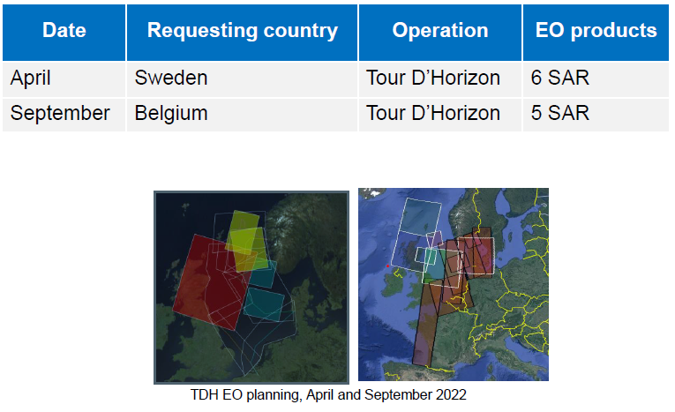
Flight routes
Four flight maps have also been added to this report. The maps visualize the flight routes of the performed TdH22 missions and the degree of coverage of the central part of the North Sea where most offshore installations are located. They also show the locations of the detections made during the various TdH22 campaigns.
Detection investigation
The overview of the national inspectors’ detection investigation is added on pp.9-11 of the TdH 2022 report. This detection investigation summary shows that of the detections associated with offshore platforms, the vast majority were reported as normal produced water discharges.

TOUR D’HORIZON 2022 RESULTS

1. SUMMARY OF RESULTS
Summary of data relating to Tour d’Horizon (TdH) flights during 2022
Country | No. of flights | No. of flight hours |  |  | No. of detections |  |  | No of detections identified as oil | Estimated volume m³ | No of ‘other substance’ detections | No of ‘unknown’ detections | No. of sources/polluters |  |  |  | Remarks
 |  | Daylight | Darkness | Sum | Daylight | Darkness | Sum |  |  |  |  | Rigs | Ships | (Unknown) | Total
Belgium | 6 | 21:40 | 00:00 | 21:40 | 16 | 0 | 16 | 15 | 3.64 | 0 | 1 | 13 | 0 | 3 | 16
Denmark |  |  |  |  |  |  |  |  |  |  |  |  |  |  |  | 1)
Germany | 0 | 00:00 | 00:00 | 00:00 | 0 | 0 | 0 | 0 | - | 0 | 0 | 0 | 0 | 0 | 0 | 2)
Netherlands | 0 | 00:00 | 00:00 | 00:00 | 0 | 0 | 0 | 0 | - | 0 | 0 | 0 | 0 | 0 | 0 | 3)
Norway | 3 | 08:17 | 00:00 | 08:17 | 0 | 0 | 0 | 0 | - | 0 | 0 | 0 | 0 | 0 | 0
Sweden | 4 | 15:38 | 00:00 | 15:38 | 5 | 0 | 5 | 4 | 0.33 | 0 | 1 | 5 | 0 | 0 | 5
UK | 5 | 14:30 | 00:00 | 14:30 | 4 | 0 | 4 | 4 | 3.40 | 0 | 0 | 4 | 0 | 0 | 4
Total | 18 | 60:05:00 | 0:00:00 | 60:05:00 | 25 | 0 | 25 | 23 | 7.37 | 0 | 2 | 22 | 0 | 3 | 25
1) DK did not provide TdH data for 2022
2) NL did not perform a TdH campaign due to the transition to a new aircraft
3) DE had to cancel its TdH campaign

2. OVERVIEW OF DETECTIONS/OBSERVATIONS PER CONTRACTING PARTY
2.1 SWEDEN: 19-22 Aril 2022.
No | Date (dd.mm.yy) | Time (UTC) | Position (dec. degr.) |  | CP Area | Min. Quan.(m³) | Max. Quan.(m³) | Source ID | Pollution type
 |  |  | N | E/W
1 | 19/04/2022 | 12:29 | 60.09 | 3.51 | NO | 0.18 | 1.83 | TROLL B | OIL
2 | 20/04/2022 | 07:45 | 61.45 | 2.14 | NO |  |  | SNORRE A | UNK
3 | 20/04/2022 | 08:15 | 61.30 | 1.90 | NO | 0.01 | 0.13 | STATFJORD NORD | OIL
4 | 20/04/2022 | 08:15 | 61.26 | 1.86 | NO | 0.06 | 0.63 | STATFJORD A | OIL
5 | 21/04/2022 | 11:50 | 55.48 | 5.11 | DK | 0.0720 | 0.7200 | DAN | OIL

2.2 UNITED KINGDOM: 28-31 August 2022.
No | Date (dd.mm.yy) | Time (UTC) | Position (dec. degr.) |  | CP Area | Min. Quan.(m³) | Max. Quan.(m³) | Source ID | Pollution type
 |  |  | N | E/W
1 | 28/08/2022 | 13:47 | 57.6933 | 0.9735 | UK | 0.96 | 9.55 | FORTIES A | OIL
2 | 29/08/2022 | 11:14 | 58.4409 | -0.2425 | UK | 0.72 | 7.26 | CLAYMORE | OIL
3 | 29/08/2022 | 11:38 | 58.4491 | 0.2651 | UK | 1.64 | 16.69 | PIPER B | OIL
4 | 29/08/2022 | 14:27 | 60.7930 | 1.4482 | UK | 0.08 | 0.81 | NINIAN SOUTHERN | OIL

2.3 BELGIUM: 05-09 September 2022.
No | Date (dd.mm.yy) | Time (UTC) | Position (dec. degr.) |  | CP Area | Min. Quan.(m³) | Max. Quan.(m³) | Source ID | Pollution type
 |  |  | N | E/W
1 | 06/09/2022 | 07:51 | 56.3717 | 3.2650 | NO | 0.01 | 0.11 | ELDFISK 2/7 S | OIL
2 | 06/09/2022 | 13:25 | 58.6866 | 1.2800 | UK | 0.00 | 0.02 | BRAE A | OIL
3 | 07/09/2022 | 13:23 | 60.7750 | 3.4966 | NO | 1.84 | 18.71 | TROLL B | OIL
4 | 07/09/2022 | 13:49 | 61.0966 | 2.2783 | NO | 0.07 | 0.50 | ASKELADDEN | OIL
5 | 07/09/2022 | 14:01 | 61.2550 | 1.8550 | NO | 0.01 | 0.08 | STRATFJORD A | OIL
6 | 07/09/2022 | 14:02 | 61.2950 | 1.8983 | NO | 0.86 | 8.63 | STRATFJORD C | OIL
7 | 07/09/2022 | 14:47 | 61.2433 | 1.0016 | UK | 0.00 | 0.04 | - | OIL
8 | 07/09/2022 | 14:48 | 61.2750 | 0.9200 | UK | 0.02 | 0.13 | TERN A | OIL
9 | 07/09/2022 | 14:55 | 61.2583 | 1.1100 | UK | 0.03 | 0.26 | NORTH CORMORANT | OIL
10 | 07/09/2022 | 15:00 | 61.1033 | 1.0716 | UK | 0.14 | 1.34 | CORMORANT A | OIL
11 | 07/09/2022 | 15:16 | 60.8550 | 1.4683 | UK | 0.01 | 0.04 | NINIAN Central | OIL
12 | 07/09/2022 | 15:16 | 60.8066 | 1.4416 | UK | 0.54 | 5.39 | NINIAN South | OIL
13 | 08/09/2022 | 10:26 | 59.1650 | 2.4800 | NO | 0.00 | 0.01 | GRANE | OIL
14 | 08/09/2022 | 10:59 | 58.3666 | 1.9016 | NO | - | - | SLEIPNER A | UNK
15 | 09/09/2022 | 10:20 | 53.0466 | 1.9950 | UK | 0.07 | 0.53 | - | OIL
16 | 09/09/2022 | 10:41 | 52.7516 | 2.4883 | UK | 0.04 | 0.27 | - | OIL

- 3 of these flight detections were verifications of a CSN SAT alert: N°3, 11, 12.
2.4 NORWAY: 03-06 October 2022.
No | Date (dd.mm.yy) | Time (UTC) | Position (dec. degr.) |  | CP Area | Min. Quan.(m³) | Max. Quan.(m³) | Source ID | Pollution type
 |  |  | N | E/W
No detections during NO TdH

TOUR D’HORIZON 2022 – DETECTION INVESTIGATION SUMMARY
SWEDEN:
Date  (ddmmyy) | Time  (UTC) | Platform | Reported quantity (m³) |  | Government inspectors assessment
 |  |  | Min. | Max.
19/04/2022 | 12:20 | TROLL B | 0.18 | 1.83 | Oil in produced water within legal limits
20/04/2022 | 07:45 | SNORRE A |  |  | Oil in produced water within legal limits
20/04/2022 | 08:15 | STATFJORD NORD | 0.01 | 0.13 | Oil in produced water within legal limits
20/04/2022 | 08:15 | STATFJORD A | 0.06 | 0.63 | Oil in produced water within legal limits
21/04/2022 | 11:50 | DAN | 0.07 | 0.72 | No DK inspectors assessment

UNITED KINGDOM:
Date  (ddmmyy) | Time  (UTC) | Platform | Reported quantity (m³) |  | Government inspectors assessment
 |  |  | Min. | Max.
28/08/2022 | 13:47 | FORTIES A | 0.96 | 9.55 | Forties A - Inspector reviewed photographs and associated report, contacted Apache and PW discharge was within permitted levels. Forties A has a surface discharge point and in flat calm conditions can be visible for miles.
29/08/2022 | 11:14 | CLAYMORE | 0.72 | 7.26 | Claymore known to have a sheen around installation even with produced water in compliance. Can have elevated figures when bringing wells back online. Check in IRS at time of overflight showed no non-compliant discharges reported.
29/08/2022 | 11:38 | PIPER B | 1.64 | 16.69 | Contacted Repsol 05/07/2023. On look back at data at the time of the overflight, the Piper B produced water discharge was in compliance and was so the next few days after. Process conditions normal at time.
29/08/2022 | 14:27 | NINIAN SOUTHERN | 0.08 | 0.81 | Ninian South do have a sheen permanently around installation even when Oil in Water figures are within regulated limits. Additional sampling undertaken when regulatory limits exceeded

BELGIUM:
Date  (ddmmyy) | Time  (UTC) | Platform | Reported quantity (m³) |  | Government inspectors assessment
 |  |  | Min. | Max.
06/09/2022 | 07:51 | ELDFISK 2/7 S | 0.01 | 0.11 | Oil in produced water within legal limits
06/09/2022 | 13:25 | BRAE A | 0.00 | 0.02 | Operator contacted. Produced water demonstrated to be in compliance with the installation's oil discharge permit discharge limit. No other emission of oil to sea was advised by the Operator.
07/09/2022 | 13:23 | TROLL B | 1.84 | 18.71 | Oil in produced water within legal limits
07/09/2022 | 13:49 | ASKELADDEN | 0.07 | 0.50 | Oil in produced water within legal limits
07/09/2022 | 14:01 | STRATFJORD A | 0.01 | 0.08 | Oil in produced water within legal limits
07/09/2022 | 14:02 | STRATFJORD C | 0.86 | 8.63 | Oil in produced water within legal limits
07/09/2022 | 14:48 | TERN A | 0.02 | 0.13 | TAQA confirm no process upset and PW within permitted levels.
07/09/2022 | 14:55 | NORTH CORMORANT | 0.03 | 0.26 | TAQA confirm no process upset. No PW discharge between 3/9/22 to 25/9/22 as platform shut down.
07/09/2022 | 15:00 | CORMORANT A | 0.14 | 1.34 | TAQA confirms no process upset. PW discharge within regulatory limits.
07/09/2022 | 15:16 | NINIAN Central | 0.01 | 0.04 | Ninian Central do have a sheen permanently around installation even when Oil in Water figures are within regulated limits. Additional sampling undertaken when regulatory limits exceeded
07/09/2022 | 15:16 | NINIAN South | 0.54 | 5.39 | Ninian South do have a sheen permanently around installation even when Oil in Water figures are within regulated limits. Additional sampling undertaken when regulatory limits exceeded
08/09/2022 | 10:26 | GRANE | 0.00 | 0.01 | No follow up due to other priorities
08/09/2022 | 10:59 | SLEIPNER A | - | - | No follow up due to other priorities

TOUR D’HORIZON 2022 – FLIGHT MAPS
SWEDEN: 19-22 April 2022.
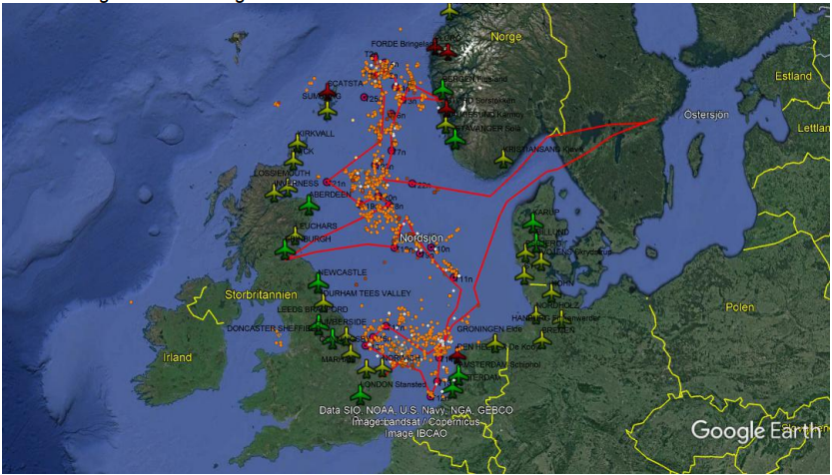

BELGIUM: 05-09 September 2022.
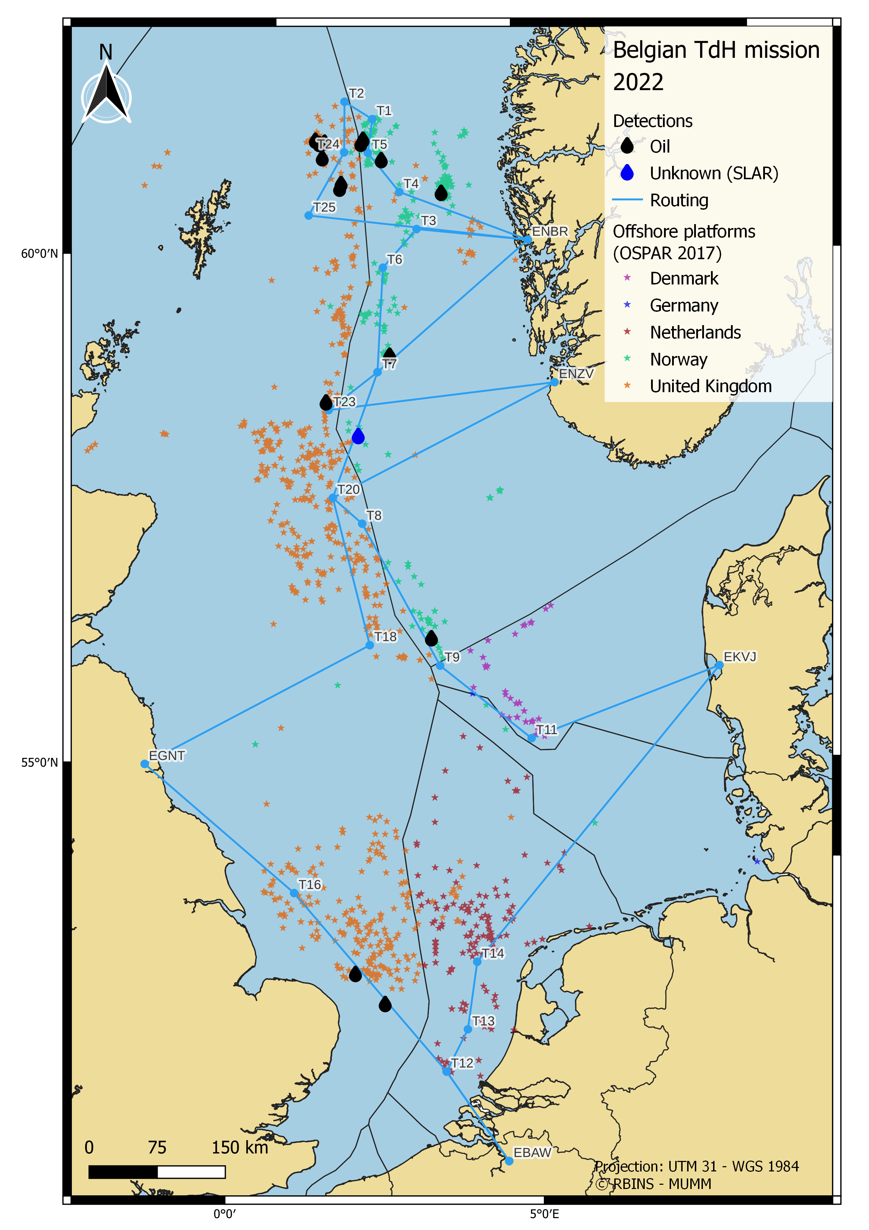

UNITED KINGDOM: 28-31 August 2022.
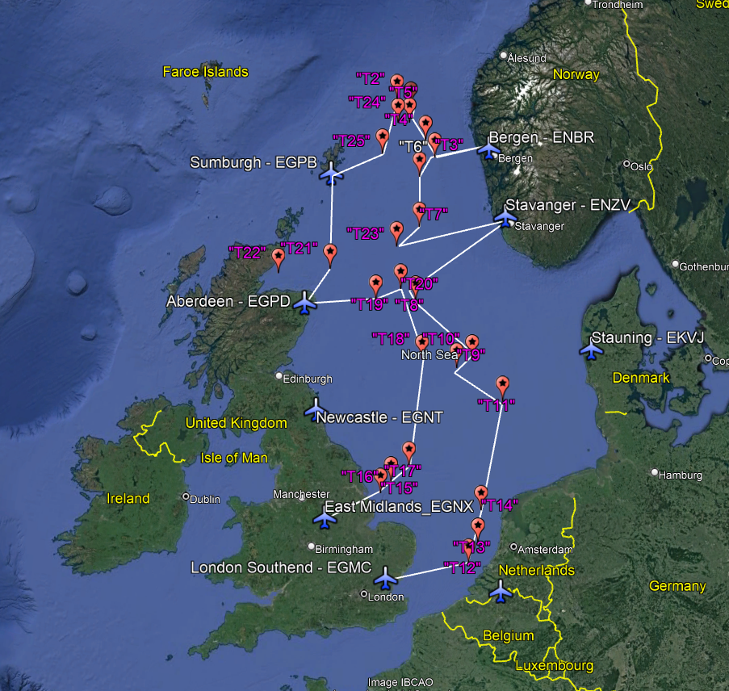
NORWAY: 03-06 October 2022.
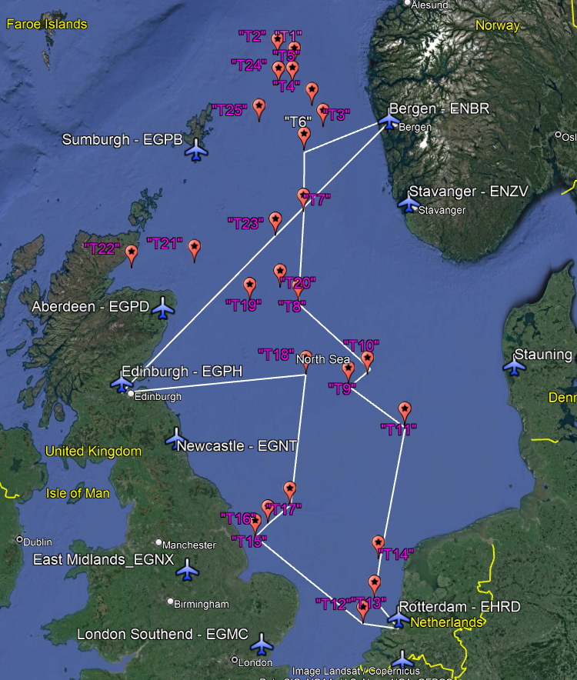

2006 is the year Belgium started compiling annual TdH reports on behalf of OTSOPA.
No data available for the DK TdH22 mission
For the period 1999-05, TdH data have been derived from the generalTdH table in the BA annual surveillance reports, which only reflect total number of detections (oil + other substances + unknowns) but not the total number of ‘major’ oil detections (>1 m³min.vol.) – therefore these data are still missing for these earlier years.
No data available for the DK TdH22 mission

