Bonn Agreement Oil Appearance Code

6 Volume Estimation - Oiled Area Measurement
6.1 Trials have shown that both oiled area and specific oil appearance area coverage measurement is the main source of error in volume estimation. Therefore observers should take particular care during this part of the volume estimation process.
6.2 Estimating or measuring the oiled area can be done either by:
- Visual estimation
- Measurement of sensor images
6.3 Estimations of oiled slick area based on visual observations are likely to be less accurate than estimates based on measurements made of remote sensing images.
6.4 If possible, the whole slick should be visible in one image for ease of area measurement. Area calculations using accurate measurements of SLAR images will be more appropriate for large oil slicks, while measurements of UV images will be more suitable for smaller slicks.
6.5 Most modern SLAR systems incorporate electronic measuring devices; areas can be measured by drawing a polygon around the detected slick. It is recommended that these devices be used where at all possible as they will provide the most accurate measurement within the confines of the aircraft during flight. Alternatively the overall length and width can be measured electronically and the oiled coverage estimated visually.
6.6 It should be remembered that because of the resolution of the SLAR (generally 20 metres) small areas of less than 20 metres NOT covered with oil but within the overall area would not show on the SLAR. However, oil patches of less than 20 metres will show up as patches of 20 metres.
6.7 The recommended procedure for visual observation is to estimate the length and width of the slick by making time and speed calculations. This forms an imaginary rectangle that encloses the slick. The coverage of the oil slick (expressed as a percentage or proportion) within this imaginary rectangle is then used to calculate the oiled area of the slick. Inevitable inaccuracies in dimension estimates and estimated coverage within these dimensions can give rise to high levels of error in area estimation.
6.8 When determining the oiled area coverage it is essential to remember that the main body of an oil slick may have 'areas' of clear water, especially near the trailing edge of the slick. For compact slicks, there may be only a few ‘clear water’ areas but for more diffused oil slicks there could be several which would lower the overall coverage percentage significantly. More accurate assessments of the oiled area can be made by a thorough analysis of the SLAR or UV images.

7 Volume Estimation - Specific Appearance Area Coverage Measurement
7.1 The ‘oiled’ area should be sub-divided into areas that relate to a specific oil appearance (see BAOAC). This can be achieved using the recorded data from the vertical sensors and the noted visual observations.
7.2 This part of the volume estimation is mainly subjective, so great care should be taken in the allocation of coverage to appearance, particularly the appearances that relate to higher thicknesses (discontinuous true colour and true colour).
7.3 The vertical camera data (if available in flight) and the visual observations should be compared with the IR data, which will give an indication of the thickest part of the slick.
7.4 Thermal IR images give an indication of the relative thickness of oil layers within a slick. Relatively thin oil layers appear to be cooler than the sea and relatively thick oil layers appear to be warmer than the sea in an IR image. There is no absolute correlation between oil layer thickness and IR image because of the variable heating and cooling effects caused by sun, clouds and air temperature.
7.5 The presence of any area within the slick shown as warm in an IR image indicates that relatively thick oil (Code 4 or 5 in the BAOAC) is present. Since these areas may only be small, but will contain a very high proportion of oil volume compared to the much thinner areas, their presence should be correlated with visual appearance in the BAOAC assessment.
7.6 The Volume Estimation Procedure is illustrated at Annex B.
7.7 It is generally considered that 90% of the oil will be contained within 10% of the overall slick (normally the leading edge (up wind side) of the slick), within a few hours after the release.

9 Oil Volume Estimate Usage
9.1 Using the BAOAC to estimate oil volume gives a maximum and minimum quantity. It is suggested that in general terms the maximum quantity should be used together with other essential information such as location to determine any required response action.
BONN CP agreed that the minimum volume estimate should be used for legal purposes. Reference is made to Bonn Agreement Contracting Parties Meeting Summary Record 2003 Page 5, Para. 2.4 (f) which states “When the BAOAC is used to estimate the quantity of oil released at sea, the lower limit of the range in the code for each coded appearance should be used for estimating the amount of oil present in the slick for enforcement purposes and for statistical reporting”. However, it is emphasised that each national authority will determine how to use the BAOAC volume data within its own area.
9.2 It is emphasised that extra caution should be used when applying the BAOAC during major incidents involving large quantities of thick oil and / or heavy oils or when emulsion is present. Aircrews should use all the available information or intelligence; such as oil thickness measurements taken by surface vessels, to estimate the volume.

11 The Bonn Agreement Oil Appearance Code

11.1 The Theory of Oil Slick Appearances
1. The visible spectrum ranges from 400 to 750 nm (0.40 – 0.75 µm). Any visible colour is a mixture of wavelengths within the visible spectrum. White is a mixture of all wavelengths; black is absence of all light.
2. The colour of an oil film depends on the way the light waves of different lengths are reflected off the oil surface, transmitted through the oil (and reflected off the water surface below the oil) and absorbed by the oil. The observed colour is the result of a combination of these factors; it is also dependant on the type of oil spilled.
3. An important parameter is optical density: the ability to block light. Distillate fuels and lubricant oils consist of the lighter fractions of crude oil and will form very thin layers that are almost transparent. Crude oils vary in their optical density; black oils block all the wavelengths to the same degree but even then there are different ‘kinds of black’, residual fuels can block all light passing through, even in thin layers.

11.2 The Bonn Agreement Oil Appearance Code
4. Since the colour of the oil itself as well as the optic effects are influenced by meteorological conditions, altitude, angle of observation and colour of the sea water, an appearance cannot be characterised purely in terms of apparent colour and therefore an ‘appearance’ code, using terms independent of specific colour names, has been developed.
5. The Bonn Agreement Oil Appearance Code has been developed as follows:
- In accordance with scientific literature and previously published scientific papers,
- Its theoretical basis is supported by small scale laboratory experiments,
- It is supported by mesoscale outdoor experiments,
- It is supported by controlled sea trials.
6. Due to slow changes in the continuum of light, overlaps in the different categories were found. However, for operational reasons, the code has been designed without these overlaps.
7. Using thickness intervals provides a biased estimation of oil volumes that can be used both for legal procedures and for response.
8. Again for operational reasons grey and silver have been combined into the generic term ‘sheen’.
9. Five levels of oil appearances are distinguished in the code detailed in the following table:

Code | Description - Appearance | Layer Thickness Interval (µm) | Litres per km²
1 | Sheen (silvery/grey) | 0.04 to 0.30 | 40 – 300
2 | Rainbow | 0.30 to 5.0 | 300 – 5000
3 | Metallic | 5.0 to 50 | 5000 – 50,000
4 | Discontinuous True Oil Colour | 50 to 200 | 50,000 – 200,000
5 | Continuous True Oil Colour | More than 200 | More than 200,000

10. The appearances described cannot be related to one thickness; they are optic effects (codes 1 - 3) or true colours (codes 4 - 5) that appear over a range of layer thickness. There is no sharp delineation between the different codes; one effect becomes more diffuse as the other strengthens. A certain degree of subjective interpretation is necessary when using the code and any choice for a specific thickness within the layer interval MUST be explained on the Standard Reporting Log.

11.3 Description of the Appearances
10.3.1 Code 1 – Sheen (0.04 µm – 0.3 µm)
11. The very thin films of oil reflect the incoming white light slightly more effectively than the surrounding water (Figure 1) and will therefore be observed as a silvery or grey sheen. The oil film is too thin for any actual colour to be observed. All oils will appear the same if they are present in these extremely thin layers.
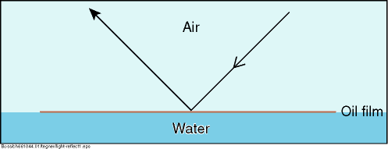

Figure 1. Light Reflecting From Very Thin Oil Films

12. Oil films below approximately 0.04-µm thickness are invisible. In poor viewing conditions even thicker films may not be observed.
13. Above a certain height or angle of view the observed film may disappear.

11.3.2 Code 2 – Rainbow (0.3 µm – 5.0 µm)
14. Rainbow oil appearance represents a range of colours: yellow, pink, purple, green, blue, red, copper and orange; this is caused by constructive and destructive interference between different wavelengths (colours) that make up white light. When white light illuminates a thin film of oil, it is reflected from both the surfaces of the oil and of the water (Figure 2).
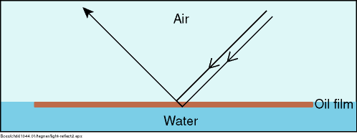

Figure 2. The Rainbow Region
15. Constructive interference occurs when the light that is reflected from the lower (oil / water) surface combines with the light that is reflected from the upper (oil / air) surface. If the light waves reinforce each other the colours will be present and brighter (Figure 3).

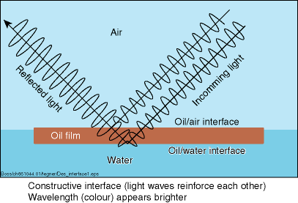

I

Figure 3. Constructive Interference
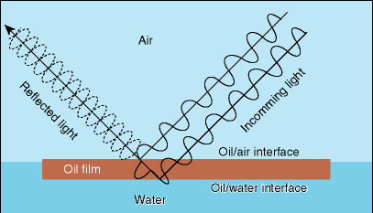
16. During destructive interference the light waves cancel each other out and the colour is reduced in the reflected light and appears darker (Figure 4).

Figure 4. Destructive Interference
17. Oil films with thicknesses near the wavelength of different coloured light, 0.2 µm – 1.5 µm (blue, 400nm or 0.4 µm, through to red, 700nm or 0.7 µm) exhibit the most distinct rainbow effect. This effect will occur up to a layer thickness of 5.0 µm.
18. All oils in films of this thickness range will show a similar tendency to produce the ‘rainbow’ effect.
19. A level layer of oil in the rainbow region will show different colours through the slick because of the change in angle of view. Therefore if rainbow is present, a range of colours will be visible.

11.3.3 Code 3 – Metallic (5.0µm – 50 µm)
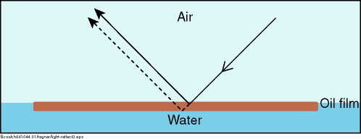
20. The appearance of the oil in this region cannot be described as a general colour. The true colour of the oil will not be present because the oil does not have sufficient optical density to block out all the light. Some of the light will pass through the oil and be reflected off the water surface. The oil will therefore act as a filter to the light (Figure 5).

Figure 5. The Metallic Region
21. The extent of filtering will depend on the optical density of the oil and the thickness of the oil film.
22. The oil appearance in this region will depend on oil colour as well as optical density and oil film thickness. Where a range of colours can be observed within a rainbow area, metallic will appear as a quite homogeneous colour that can be blue, brown, purple or another colour. The ‘metallic’ appearance is the common factor and has been identified as a mirror effect, dependent on light and sky conditions. For example blue can be observed in blue-sky.

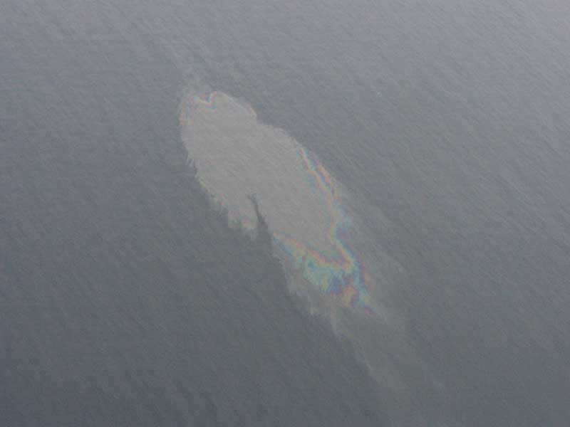

RAINBOW
METALLIC

SHEEN

11.3.4 Code 4 – Discontinuous True Colours (50 µm – 200 µm)
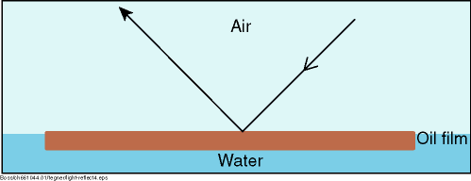
23. For oil films thicker than 50 µm the light is being reflected from the oil surface rather than the sea surface (Figure 6).

Figure 6. Thick Oil Films
24. The true colour of the oil will gradually dominate the colour that is observed. Brown oils will appear brown, black oils will appear black.
25. In this appearance category the broken nature of the colour, due to thinner areas within the slick, is described as discontinuous. This is caused by the spreading behaviour under the effects of wind and current.
26. ‘Discontinuous’ should not be mistaken for ‘coverage’. Discontinuous implies colour variations and not non-polluted areas.
27. ‘Discontinuous true colour’ appeared to be a difficult appearance to describe and through imagery it may be possible to get a clearer picture of what is meant. For now the best result of the elaborations is: “true oil colour against a background of metallic”.
28. When oil is moved by waves, the oil layer obviously is thicker in the wave-trough than on the wave-top. This variation of the “oil appearance” may be understood by indicating “discontinuous”.

11.3.5 Code 5 – True Colours (>200 µm)
27. The true colour of the specific oil is the dominant effect in this category.
28. A more homogenous colour can be observed with no discontinuity as described in Code 4.
29. This category is strongly oil type dependent and colours may be more diffuse in overcast conditions.

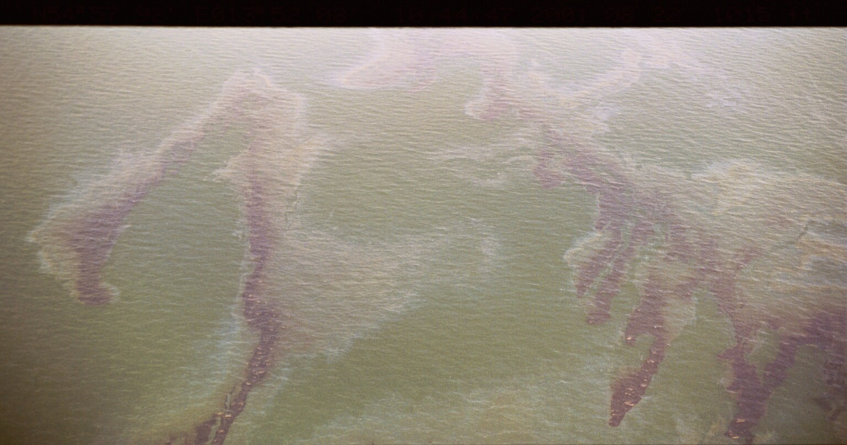
TRUE COLOUR

Note: all documentation on the study can be downloaded from the Bonn Agreement web-site under publications, at: www.bonnagreement.org

ANNEX A
THE VOLUME ESTIMATION PROCEDURE
1. Oiled Area Measurement

SLAR Polygon
Area from SLAR Data 12 km²
Length and Width (SLAR Image or Time and Distance)
Length – 12 km x Width – 2 km (Imaginary Rectangle)
Area Covered with oil (Coverage) – 50%
Oiled Area 12 x 2 x 50% 12 km²

2. Appearance Coverage Allocation
Appearance Code 1 (Sheen) 50%
Appearance 2 (Rainbow) 30%
Appearance 3 (Metallic) 15%
Appearance 5 (True Colour) 5%

3. Thickness Band for Allocated Appearance
Sheen 0.04 µm – 0.3 µm
Rainbow 0.3 µm – 5.0µm
Metallic 5.0 µm – 50 µm
True Colour More than 200 µm

4. Minimum Volume Calculation
Oiled Area x Area Covered with Specific Appearance x Minimum Thickness
Appearance 1 (Sheen)
12 km² x 50% x 0.04 µm = 0.24 m³
Appearance 2 (Rainbow)
12 km² x 30% x 0.3 µm = 1.08 m³
Appearance 3 (Metallic)
12 km² x 15% x 5.0 µm = 9 m³
Appearance 5 (True Colour)
12 km² x 5% x 200 µm = 120.0 m³

Minimum Volume = 0.24 + 1.08 + 9 + 120 = 130.32 m³

6. Maximum Volume Calculation
Oiled Area x Area Covered with Specific Appearance x Maximum Thickness
Appearance 1 (Sheen)
12 km² x 50% x 0.3 µm = 1.8 m³
Appearance 2 (Rainbow)
12 km² x 30% x 5 µm = 18 m³
Appearance 3 (Metallic)
12 km² x 15% x 50 µm = 90.0 m³
Appearance 5 (True Colour)
12 km² x 5% x (more than) > 200 µm = > 120.0 m³

Maximum Volume = 1.8 + 18+ 90.0 + > 120 = > 229.8 m³

